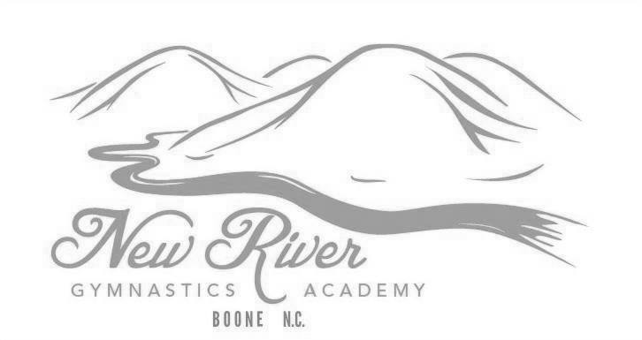
2021 MEMBERSHIP FORM

Form must be completed before the student can participate. This form is good for the full 2021 year. Please notify us immediately of any changes. It is the parent's responsibility to re- register their student for every semester (Spring, Summer, and Fall) when NRGA changes their schedule.

Student’s Full Name: _____________________________________________________________________________

Preferred Name: ________________________________ Age: ________ DOB: ______/______/__________

Parent’s Email(s): ___________________________________________________________________________________
Your email will be added to our email list. You will receive updates on important gym information such as closings, prorated tuition, etc.

Billing Address: ______________________________________________________________________________________
Address City State Zip Code

******************************************************************************************************************************************************
**PLEASE READ OUR ENROLLMENT POLICIES BELOW. YOUR SIGNED INITIALS STATE THAT YOU UNDERSTAND AND AGREE TO ABIDE BY THE POLICIES. OUR FULL RULES AND POLICIES DOCUMENT IS ON OUR WEBSITE.**

FEES: A $15 semiannual (January-June / July-December) membership fee is required for all students to participate in classes. Instructional fee for the month is due by the 1st of each month for recreational students. Failure to pay by the 1st of the month (unless otherwise posted or authorized by the Manager) will result in a $10 late fee and denial of participation. We only accept cash and checks. There is a $25 returned check fee. Overpayments will result in an account credit which will continue to roll over until used. Open Gym and Private Lesson fees must be paid before each class to participate.

___________
INITIALS

___________
INITIALS

___________
INITIALS

NRGA DOES NOT ISSUE REFUNDS!

WITHDRAWING FROM CLASS: When registering, you are committing to all months of a given semester (Spring runs January-May, Summer runs June-July/August, and Fall runs August-December). If you cannot complete the semester term you are registered in for any reason, you must send email notification of the withdraw seven days before the 1st of the upcoming month to not be charged for that month. You are responsible for paying for any and all classes the student attended or was scheduled to attend. NRGA will automatically withdraw students with unpaid accounts unless payment plans have been discussed PRIOR with the Manager. It is the parent/guardian's responsibility to communicate payment questions with the Manager prior to the due date.

ADDITIONAL RULES: Additional rules and policies can be found in our 2021 Rules and Policies document on the main page of our website.I have read over this document and agree that my gymnast and I will abide by all rules and policies set by New River Gymnastics Academy. I understand rules and rolicies are subject to change.

*****************************************************************************************************************************************************
RELEASE/ WAIVER: I am fully aware of and appreciate the risks of injury, possibly catastrophic injury, which may occur with sport related activities including gymnastics and parkour. I hereby release from liability New River Gymnastics Academy L.P. DBA Gymnastics World, and its employees, agents, officers, and directors regarding any and all injuries sustained by me/ my child during instruction classes at New River Gymnastics Academy, L.P. (NRGA) I certify that I am / the above student is in good health and able to participate in gymnastics and parkour activities. As the parent or legal guardian of the above student, or I being the registering student, I hereby agree to individually protect for the possible future medical expenses, which may be incurred by myself/my child as a result of any injury, sustained while training at, for, or under the direction of NRGA staff. My child and / or I have read, understand, and agree to abide by the rules and policies set by NRGA.

MEDICAL TREATMENT WAIVER: In the event that I / my child is injured or incapacitated while at New River Gymnastics Academy L.P. (NRGA), I authorize the employees, agents, officers, and directors to secure medical treatment. I fully understand the NRGA staff members are not physicians or medical practitioners of any kind. With this in mind, I hereby grant permission for NRGA staff to provide temporary first aid to my child / me in the event of any injury or illness, and if deemed necessary by the NRGA staff to transport student by ambulance to Watauga Medical Center in Boone, N.C. (336 Deerfield Road).

___________________________________ ___/___/______
Signature of Parent/ Guardian/ Student (if over 18 years old) Date Signed

PLEASE COMPLETE THE MEDICAL FORM ON REVERSE SIDE
REV 1/21

2021 MEDICAL FORM

Form must be filled out completely before student can participate. This form is good for the full 2021 year. Please notify us immediately of any changes.

Student’s Full Name: ____________________________________________________________________________

Preferred Name: _________________________________ Age: _______ DOB: ______/______/_________

Student's Insurance Carrier: ___________________________________________ Check If No Insurance

********************************************************************************************************************************

Describe any physical or psychological limitations, allergies, or any other pertinent information NRGA should be aware of. Also provide any specific instructions for our staff to better understand or help in regard to the student's limitations or any other special circumstances.
______________________________________________________________________________________________________________________________________________________________________________________________________
Physical/ Examination Information:

Has the student obtained a physical examination within the past 12 months? Yes No

What year was the last physical examination completed? ___________

NRGA highly recommends all students obtain a physical examination within 12 months of participating. While the physical is not a requirement, by signing this form and allowing them to participate, you are acknowledging that you believe they are healthy enough to be involved in gymnastics related activities.

Chronic ailments including, but not limited to:

Respiratory Problems (i.e.- asthma): Yes No
Circulatory/ Heart Problems: Yes No
Diabetes or Hypoglycemia: Yes No
Epilepsy: Yes No
ADD/ADHD: Yes No
Other: __________________________________________

Further details on above information: ______________________________________________________________________________________________________________________________________________________________________________________________________

********************************************************************************************************************************

Parent/ Guardian Contact Information:

1) _________________________________________________________________________________________________________________________________
Name Relationship Phone number

2) _________________________________________________________________________________________________________________________________
Name Relationship Phone number

Additional Emergency Contacts: (These will be contacted if we are unable to reach you in case of an emergency)

1) _________________________________________________________________________________________________________________________________
Name Relationship Phone number

2) _________________________________________________________________________________________________________________________________
Name Relationship Phone number

3) ________________________________________________________________________________________________________________________________
Name Relationship Phone number

I will keep New River Gymnastics Academy updated on any changes to the above information.

__________________________________ ___/___/_____
Signature of Parent/ Guardian/ Student (if over 18 years old) Date Signed

PLEASE COMPLETE THE MEMBERSHIP FORM ON REVERSE SIDE
REV 1/21

